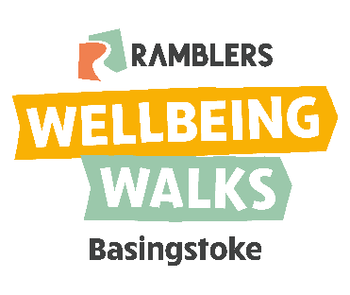
Basingstoke Wellbeing Walks
May 2022 program
Pace |  | Length
Slow | This is at a slow pace | Short | Takes up to 30 minutes
Medium | Is at a medium pace | Medium | Takes up to 60 minutes
Fast | This is at brisk pace | Long | Takes up to 90 minutes

Walk | Starting place | Pace | Length | Day | Start time | May 2022 dates
Walks on Mondays
Eastrop Park | Eastrop Park, Boating Lake | Medium | Medium | Monday | 11am | 2, 9, 16, 23, 30 May 2022
Walks on Tuesdays
Walks on Wednesdays
Aquadrome – Medium | Outside the Aquadrome in the leisure park | Medium | Medium | Wednesday | 11am | 4, 11, 18, 25 May 2022
Aquadrome – Fast | Outside the Aquadrome in the leisure park | Fast | Medium | Wednesday | 11am | 4, 11, 18, 25 May 2022
Beggarwood | Café, The Park, Broadmere Lane, RG22 4AQ | Medium | Medium/Long | Wednesday | 11am | 4 May 2022
Walks on Thursdays
Baughurst | Baughurst Scout Hut, The Den, Ash Lane RG26 5PW | Medium | Long | Thursday | 10:30 am | 12, 26 May 2022
Down Grange | Walled Garden Down Grange Walk (meet by Hockey Club Pavilion) accessible from Pack Lane | Medium | Long | Thursday | 11am | 5, 12, 19, 26 May 2022
Walks on Fridays
Popley - Medium | Shakespeare Medical Centre | Medium | Medium | Friday | 11am | 6, 13, 20, 27 May 2022
Popley – Slow | Shakespeare Medical Centre | Slow | Short | Friday | 11am | 13, 20, 27 May 2022
Tadley - Medium | Tadley library | Medium | Medium | Friday | 2pm | 6 May 2022
Oakley Woodland | School layby in Oakley, RG23 7JZ | Slow | Medium | Friday | 10:30am | 13 May 2022
Walks on Sundays
Oakley | Beach car park (off B3400 in Oakley) | Medium | Medium | Sunday | 2:30pm | 29 May 2022
For more information please email: walks@bvaction.org.uk

